PRESS RELEASE
COMMUNICATIONS AND MEDIA TEAM OF THE 43RD ASEAN SUMMIT 2023
No. 56/SP/TKM-ASEAN2023/ENG/9/2023

ASEAN Economy Shows Positive Performance
Jakarta, 4 September 2023 – The ASEAN region has demonstrated positive performance over the past decade with an average growth rate of 4% - 5%. The ASEAN region is the fifth-largest economy and the fourth-largest exporter in the world. In 2022, the ASEAN region was also the second-largest destination for foreign direct investment (FDI).
This was stated by the Coordinating Minister for Economic Affairs Airlangga Hartarto in an official statement received by the Communications and Media Team of the 43rd ASEAN Summit on Monday (4 September 2023).
“Today, our region is one of the few bright spots for economic growth,” said the coordinating minister.
Leading up to the summit, there were two meetings that specifically highlighted the collaboration of public-private sectors in ASEAN. The first one was the ASEAN Business and Investment Summit 2023 Plenary Session with the theme “Aligning ASEAN’s Private Sector Priorities to the Global Agenda”.
The second meeting was the ASEAN Business Advisory Council 2023 meeting with the theme “ASEAN Centrality: Innovating towards Greater Inclusivity”. Both events were held on Sunday (3 September 2023).
Hartarto said that during the meeting, Indonesia emphasized that ASEAN cooperation is not solely the responsibility of the public sector. Instead, the key lies in the inclusive and collaborative efforts of the private sector in various ASEAN agendas and initiatives.
The ASEAN economy recorded a growth rate of 5.7% in 2022, driven by high levels of domestic consumption, trade, and investment. Industries such as electronics, electric vehicles, and the digital economy saw increased investments last year, with a total FDI inflow increased by 5.5%.
Projects with economic value in ASEAN are also influenced by global dynamics, making the active role of both public and private sectors necessary.
According to the coordinating minister, there are three priority areas that offer opportunities for the private sector to contribute to the global agenda.
“First, we need a stronger voice from the private sector to highlight and reduce the risks and costs of global and regional supply chain fragmentation driven by geopolitics. The public and private sectors need to cooperate, including with partners and other platforms, to uphold an open, inclusive, non-discriminatory, and rules-based architecture for trade and economy,” he said.
Secondly, he said that an active private sector is needed to capitalize on new growth opportunities. The ASEAN private sector should collaborate with other business councils to explore collaboration potential. The ASEAN private sector should also implement an inclusive business model and optimize relationships with local economic development, including micro, small, and medium-sized enterprises (MSMEs).
Thirdly, the ASEAN private sector needs to harness its resources, networks, technology, and expertise to address socio-economic challenges and climate change in the region. Innovation, technology diffusion, and adoption also need to be supported and accelerated to improve regional economic resilience and people’s welfare.
“The road ahead is still shrouded in uncertainty. Global economic growth is expected to slow down in the coming years. There are already signs of slowing economic performance in key ASEAN countries, rising food inflation, and ongoing market uncertainty due to geopolitical fragmentation,” said the Coordinating Minister Airlangga Hartarto.
Based on the theme of Indonesia’s ASEAN Chairmanship in 2023, “ASEAN Matters: Epicentrum of Growth”, Indonesia has taken several initiatives. One of them is strengthening regional market integration through the enhancement of the ASEAN-Australia-New Zealand Free Trade Agreement, introducing local currency transactions and digital payment interoperability, and promoting the ASEAN Industry Project-Based Initiative.
There is also the recently launched ASEAN Digital Economy Framework Agreement (DEFA) which aims to double the value of the digital economy in ASEAN by 2030.
Regarding DEFA, the Coordinating Minister Airlangga Hartarto held discussions with Council Members of the ASEAN Business Advisory Council (BAC) Malaysia Chapter during a bilateral meeting on the sidelines of the ASEAN Business Investment Summit (ABIS) 2023. The implementation of DEFA will commence in 2025 during Malaysia’s ASEAN Chairmanship.
The Malaysian delegation was led by the Deputy Chairman of the ASEAN-BAC Malaysia Chapter, Tan Sri Tony Fernandes, accompanied by Council Member Lim Chern Yuan, Executive Director of the ASEAN-BAC Malaysia Chapter Jukhee Hong, and representatives from several prominent Malaysian companies. The bilateral meeting discussed several issues, including cross-border trade and payment systems, as well as developments of electric vehicles (EVs). The Coordinating Minister Airlangga Hartarto also emphasized the importance of connectivity and interoperability during the meeting.
The main focus of the ASEAN-BAC is to facilitate trade and investment, as well as attract FDI. The ASEAN-BAC should be capable of driving the implementation of key priorities to strengthen intra-ASEAN trade and investment. Indonesia will also simplify the immigration process by creating an integrated digital system among relevant ministries and agencies, commonly referred to as e-government.
The next steps involve strengthening regional trade and investment relationships as well as promoting collaborative sustainable development actions. Several areas to explore include launching environmentally friendly energy projects such as solar power generation and connecting ASEAN through strategic tools and a Regional QR payment system.
“In the future, Indonesian people traveling to Malaysia, Thailand, Singapore, or other ASEAN countries will be able to make payments using QR codes. Indonesia has already widely adopted QRIS in many retail outlets. QRIS was developed by Bank Indonesia and its transaction value is continuously increasing,” added Hartarto.
He also said that the ASEAN region is rich in natural energy resources, which can drive global energy demand that will benefit ASEAN.
“As part of sustainability, we should also promote the establishment of a carbon credit market in ASEAN. Furthermore, our future task is to develop downstream industries as a key point in the global supply chain,” he said.
Tan Sri Tony Fernandes welcomed Indonesia’s initiative. “We are very excited about ASEAN, about Indonesia. We must commend the Indonesian Government. This opens our eyes to the fact that Indonesia is highly progressive (in terms of economy), and also very open and transparent (in terms of governance),” he said.
***
For more information, please contact:
Director General of Public Information and Communications of the Ministry of Communications and Informatics – Usman Kansong (0816785320).
Get more information at http://asean2023.id, https://infopublik.id/kategori/asean-2023, and https://indonesia.go.id/kategori/ragam-asean-2023

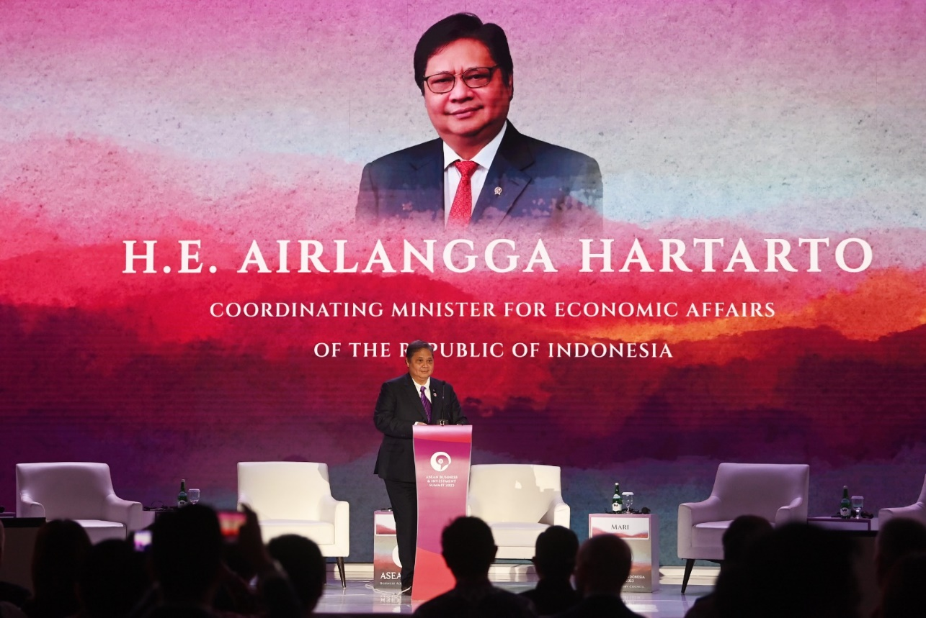
The Indonesian Coordinating Minister for Economic Affairs Airlangga Hartarto delivers a speech during the third plenary session of the ASEAN Business and Investment Summit 2023 in Jakarta on Sunday (3 September 2023). Media Center KTT ASEAN 2023/Zabur Karuru/aww

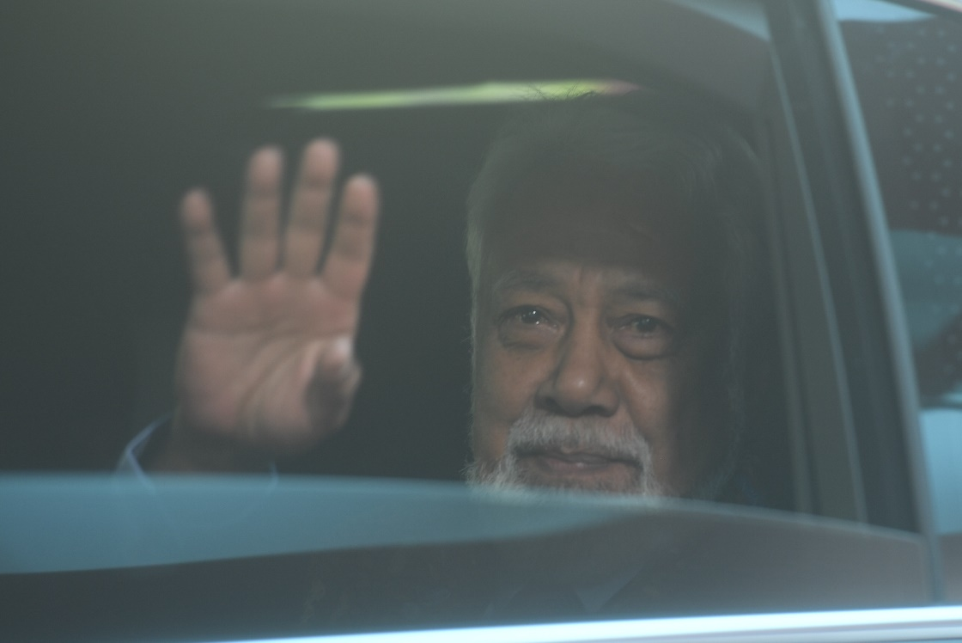

Prime Minister of Timor-Leste Xanana Gusmao waved from inside a vehicle upon arrival at the VVIP Building of Terminal 3 of Soekarno-Hatta Airport in Banten on Monday (4 September 2023). ANTARA FOTO/Media Center KTT ASEAN 2023/Muhammad Adimaja/aww.

